AWARD CRITERIA
Who’s Eligible?
LAUNCH Fostoria is open to anyone interested in opening or growing a business in Fostoria.
Businesses must be for-profit
May not have earned more than $250,000 in the past year revenue

TIMELINE
April 5 Application Opens**
May 7 Application Deadline
May 11-13 Application Review and Selection
May 14 Contest Decision Notice
May 19 Pitch Clinic: a best practice of how to pitch
June 16 Semi Finals: First round of pitches to judges only including Q&A
July 22 Required dress rehearsal and tech check for Finals
July 23 Finals: Public Event where finalists will pitch and the public will vote on winner

APPLICATION
Business Name:
Primary Business Contact Name:
Address:
Phone:
Cell Phone:
Email:
Preferred Method of Communication: Phone Cell Phone Email
Highest Level of Education Obtained:
- Less than High School
- High School Diploma, GED, or GED equivalent
- Some College, Associate or Technical Degree (please specify Degree)__________________________________________
- Bachelor’s Degree (please specify Degree) ________________________________________________
- Graduate Degree (please specify Degree) ________________________________________________

Please provide a professional profile of your background and business history (for example your prior business ventures or experience related to your proposed business).

How many of the following relationships do you maintain with your commercial bank? Check all that apply.
- Personal Transaction Accounts (Checking, Savings, loan accounts)
- Investment Accounts
- Mortgage Accounts
- Business Transaction Accounts (Business Checking, Savings)
- Business Loan(s)
- Merchant Services (credit card accounts)
- Trust Services
- Insurance Accounts
- Payroll Services
- Cash Management
- Other (please specify): ________________________________________

Primary Product or Service Offering:

What is the target market for your business (for example, who are your proposed customers)?

What other local businesses offer the same products/services your business will offer?

Describe the purpose of the business that you propose. (For example, mission statement, goals, objectives and overall vision)

What motivates you to own a business? (Check all that apply)
- Be your own boss
- Good at your craft
- Lost your job
- Flexibility
- Turn your hobby into a business
- Desire to make money
- No one else is doing it
- Other, please specify: __________________________________________________________

Do you have a formal business plan and/or Canvas? YES NO
(If yes, please attach your business plan to the application.)

Do you currently own a business? YES NO

Is your personal credit score at a creditworthy level (higher than 700)? YES NO

Do you have any negative credit experience, personal or professional?
YES NO If yes, please explain:

Identify the source(s) of your start-up capital (beginning funding-check all that apply):
- Personal or Family Savings
- Personal or Family Assets
- Personal or Business Credit Card
- Commercial Bank Loan
- Government Guaranteed Bank Loan
- Collaborators or Investors
- Family Members
- Other (please specify): _______________________________________________

How much funding have your raised to date?

What sets apart your business from your competition?

What technology will you be using in your business? (computers, accounting or other specialized software, website creation, credit card transactions, mobile apps, etc.)

Personal Involvement in Business Full-Time Part-Time

What is your management plan (what will your organizational structure be, how many employees do you intend to hire, including full and part time)?

Why are you choosing to open your business in the Fostoria area?

What need will your proposed business meet? How have you determined this need exists in Fostoria?

What will I win? (current value $19,965)
One Year Lease in Downtown Fostoria (approx. value $8,000)
Advertising Package: Print ads in The Review Times (valued at $490)
Radio ads on WKXA, The Fox, WFIN (approx.. value $1,000)
Branding/Marketing Services from JYoakam Communications (approx. value $5,000)
Trainings at the FLC by NW State Community College (approx. value $500)
$1,000 from Shuff Family Small Business-Entrepreneur Grant
Additional trainings/courses at FLC (approx. value $400)
One Year Chamber Membership ($200)
One hour legal advising (approx. value $250)
Three hours accounting advising (approx. value $875)
Co.Starters Course ($250)
Winner Requirements
Report their award use and expenditure
Complete a business financial tracking form for three years after the award is received
Document quarterly for the first year with photos if applicable the use of the award the impact of the award
Be available for Social Media, blog, and website marketing
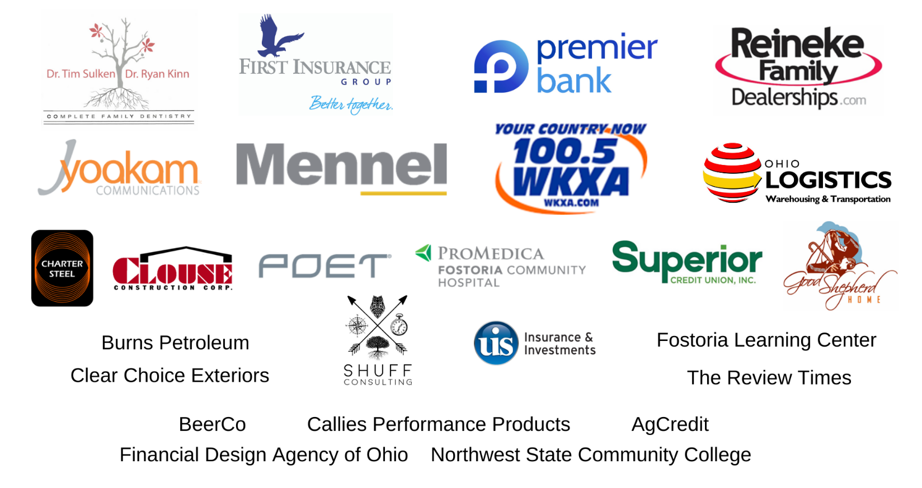
Return to next year’s finale and provide business updates
Sponsors

